HD 50499

HD 50499 is a 1.31 M☉, G1 V star1. Based on 101 RV HIRES measurements obtained between 1996 and 2020, The CL survey reported a GP (HD 50499b) with a period of days, a minimum mass of MJup and an eccentricity of as well as a LPGP (HD 50499c) signal with a period of days, a minimum mass of MJup and an eccentricity of . The CH survey reported only HD 50499b with properties close to those of the CL survey.

In the present study, in addition to the CL survey’s dataset, 123 RV CORALIE measurements obtained between 1999 and 2019 and 29 RV HARPS measurements obtained between 2014 and 2019 were used. DPASS and MCMC (1000 walkers and 400000 iterations) were used to fit the data. The properties found for HD 50499b reported in the CL survey were within the error bars associated with the values found in the present analysis. For HD 50499c, a period of 9000 days, a minimum mass of 2.7 MJup and an eccentricity of 0.18 were found with DPASS, with a corresponding rms of residuals of 5.9 m/s, and a period between 8500 and 19700 days, a minimum mass between 2.6 and 4.6 MJup and an eccentricity between 0.14 and 0.35 were found using MCMC. As the RV curve of HD 50499c covers only a minimum, the period (or *a*) and the stellar RV offset are actually not well constrained.

To explore the range of possible values, the semi-major axis was fixed to different values and the data fitted with DPASS. *a* up to 100 au do not significantly change the rms of the residuals (6.3 m/s against 5.9 m/s with *a* left free). In this case (referred to as constrained *a*), the minimum mass is 4.8 MJup and the extremely high eccentricity is 0.92.

To test the impact of the stellar RV offset, it was also fixed to different values and the data, once corrected for the instrumental offsets for clarity purposes, were fitted with DPASS. It appears that stellar RV offset up to 75 m/s does not significantly change the rms of the residuals (6.8 m/s against 5.9 m/s with stellar RV offset left free). In this case (referred to as constrained offset), the *a* is 24 au, the minimum mass is 14 MJup and the eccentricity is 0.31.

The fits are shown in Fig 1, and the corner plot in Fig 2, and the results summarized in Table 1.

Conclusion: The orbital parameters of HD 50499b used in the CH and the CL survey are confirmed. However, the properties of HD 50499c used in the CL survey are not confirmed. Additional data are needed to further constrain its orbital properties.

Figure S48: Top left: fit of the HD 50499 RV with DPASS. Red - C98, green - C07, blue - C14, cyan - Hir94, purple - Hir04, yellow - H03, orange - H15. The blue curve shows the best fit. Top right: fit of the HD 50499 RV with DPASS, with the minimum *a* fixed at 100 au. The points are the same as on the left. The blue curve shows the best fit. Bottom left: fit of the HD 50499 RV with DPASS, with a subtracted stellar RV offset fixed to 75 m/s. Black points correspond to the data corrected for the instrumental offsets. The blue curve shows the best fit. Bottom right: fit of the HD 50499 RV using MCMC. The black curve shows the best fit. The colorbar corresponds to the log-likelihood of the fits. The gray dotted line indicates the end of the CH survey.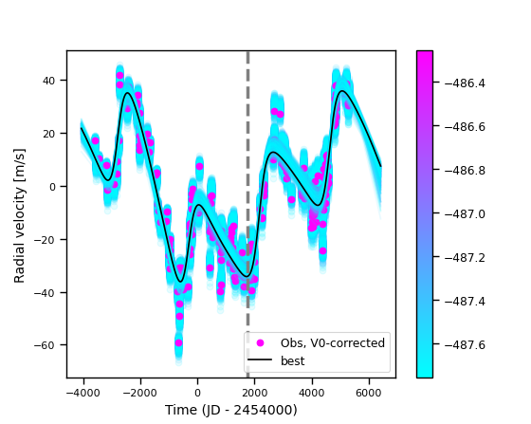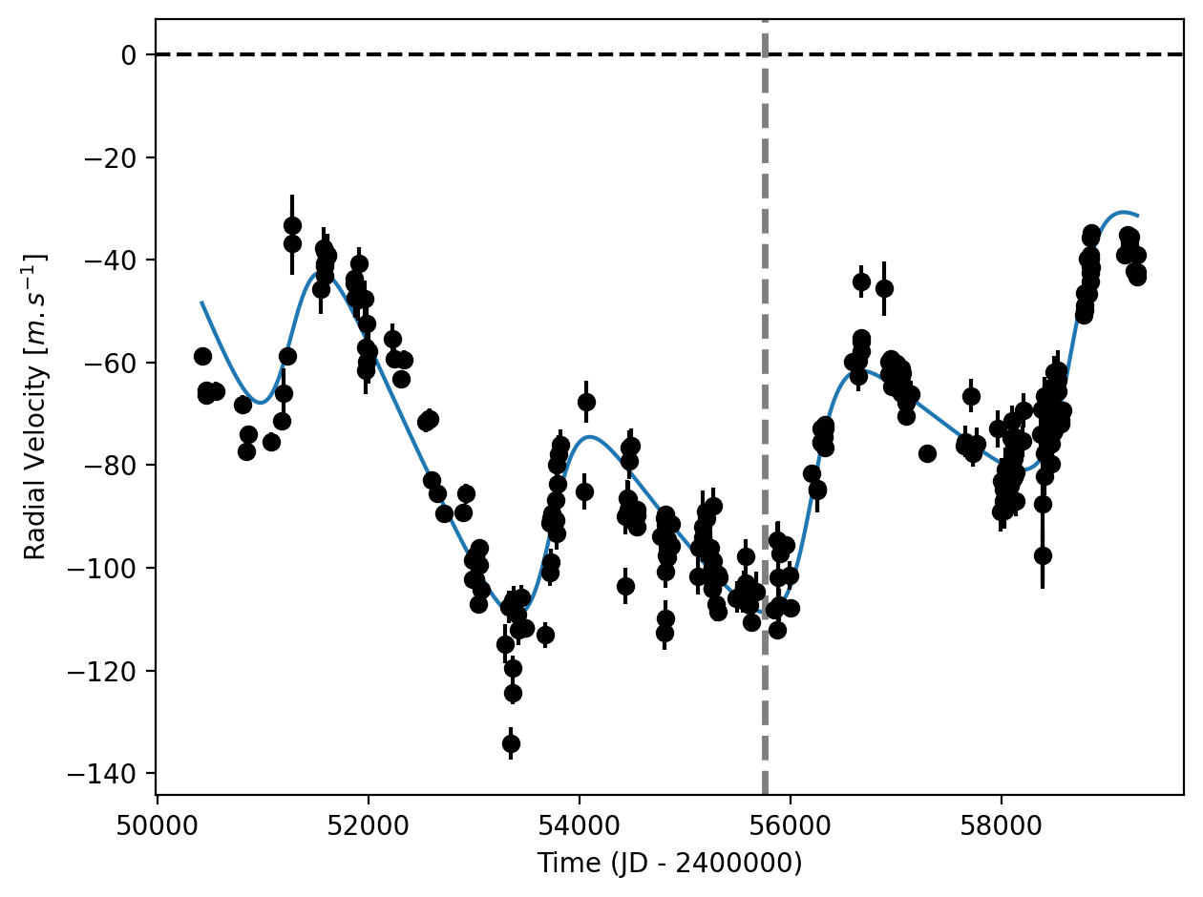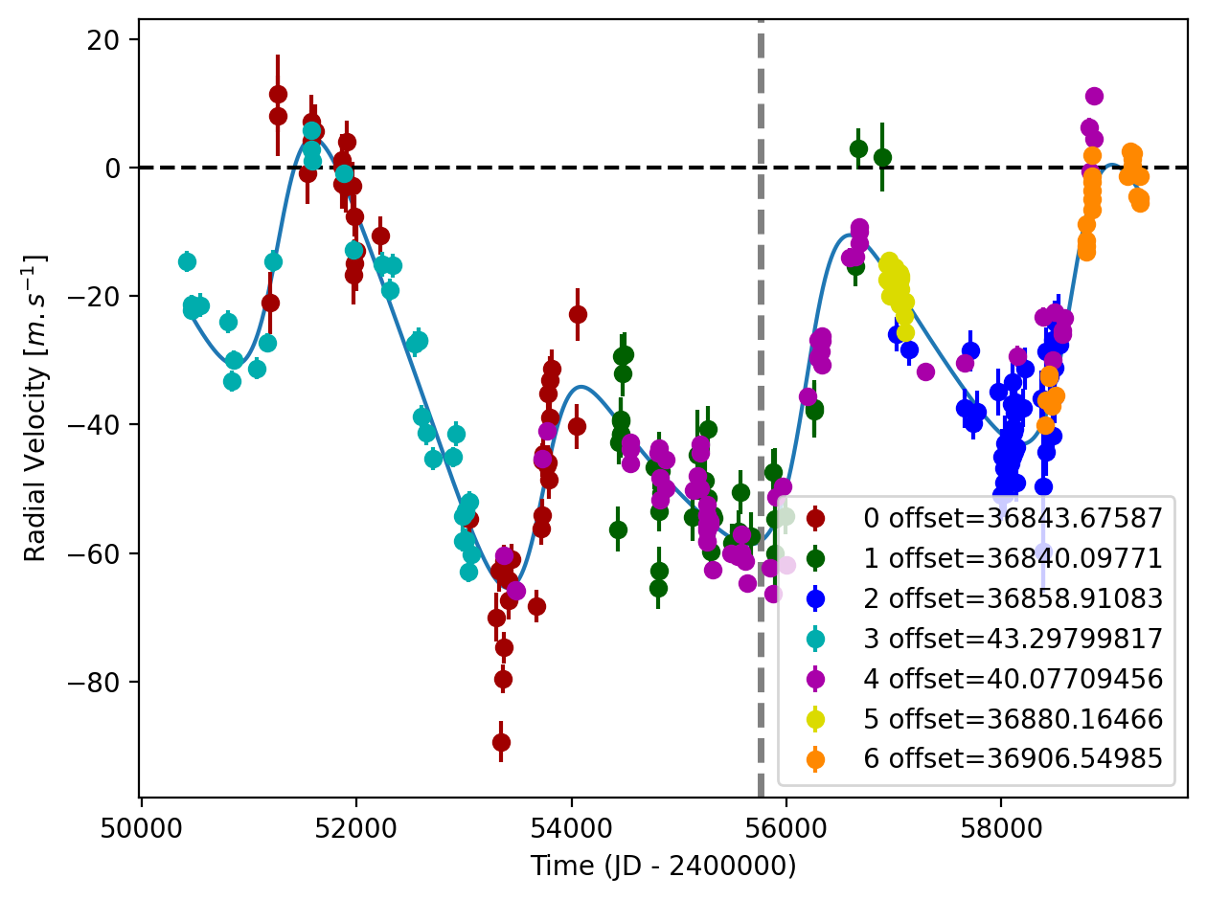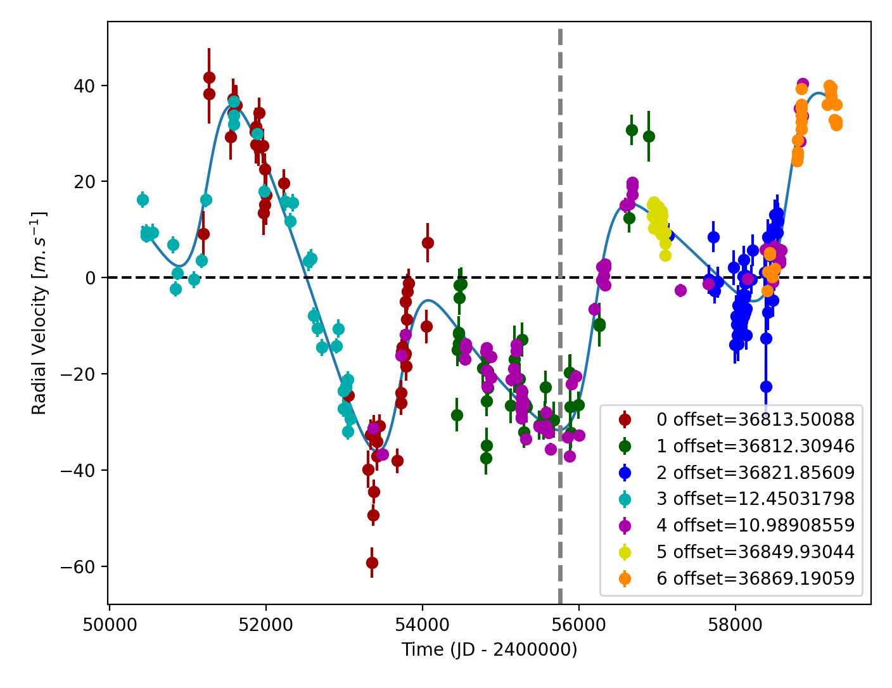

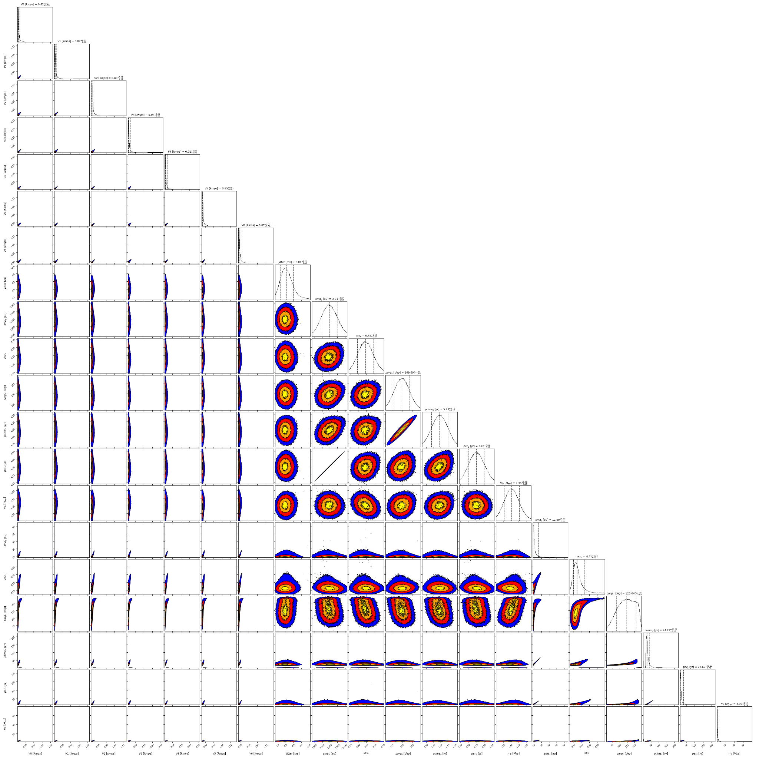

Figure S12: Corner plot of posteriors for the two-planets model MCMC fit of HD 50499 RV data.

| Parameter | Priors | | | | Posteriors | | | | CH/CL survey |
| --- | --- | --- | --- | --- | --- | --- | --- | --- | --- |
|  | DPASS | | | MCMC | DPASS | | | MCMC |  |
|  | Free priors | Constrained *a* | Constrained offset | Free priors | Free priors | Constrained *a* | Constrained offset | Free priors |  |
| *a* (au) | b: [0,100]  c: [0,100] | b: [0,6]  c: up to 85.2 | b: [2,4]  c: [0,100] | b: [1,5]  c: [1,40] | b = 3.92  c = 9.3 | b = 3.9  c = 100 | b = 3.9  c = 24 | b =  c = 8.9 – 15.7 | CH survey:  b = 3.9  CL survey:  b =  c = |
| Msin(i) (MJup) | b: [0,100]  c: [0,100] | b: [0,100]  c: [0,1000] | b: [0,10]  c: [0,100] | b: [0.1,5]  c: [1,40] | b = 1.42  c = 2.7 | b = 1.58  c = 4.8 | b = 1.48  c = 14 | b = 1.45 ± 0.08  c = 2.6 – 4.6 | CH survey:  b = 1.74  CL survey:  b =  c = |
| Eccentricity | b: [0,0.95]  c: [0,0.95] | b: [0,0.95]  c: [0,0.95] | b: [0,0.95]  c: [0,0.95] | b: [0,0.9]  c: [0,0.9] | b = 0.32  c = 0.18 | b = 0.28  c = 0.92 | b = 0.30  c = 0.31 | b =  c = 0.14 – 0.35 | CH survey:  b = 0.25  CL survey:  b =  c = |
| Instrumentals offsets (km/s) | [-100,100] | [-100,100] | up to 0.075 | C98: [35,37]  C07: [35,37]  C14: [35,37]  Hir94: [-1,1]  Hir04: [-1,1]  H04: [35,37]  H15: [35,37] | C98: 36.814  C07: 36.812  C14: 36.822  Hir94: 0.013  Hir04: 0.011  H04: 36.850  H15: 36.869 | C98: 36.844  C07: 36.840  C14: 36.859  Hir94: 0.043  Hir04: 0.040  H04: 36.880  H15: 36.907 | 0.075 | C98: 0.812 – 0.832  C07: 0.810 – 0.832  C14: 0.819 – 0.841  Hir94: 0.011 – 0.030  Hir04: 0.009 – 0.029  H04: 0.847 – 0.867  H15: 0.868 – 0.888 |  |
| Stellar jitter (m/s) | [0,40] | [0,40] | [0,40] | [0,100] | 7.3 | 8.1 | 8.8 |  |  |
| Argument of periastron (°) | b: [0,360]  c: [0,360] | b: [0,360]  c: [0,360] | b: [0,360]  c: [0,360] | b: [0,360]  c: [0,360] | b = 270  c = 107 | b = 280  c = 161 | b = 270  c = 150 | b = 270 ± 12  c = 90 – 155 |  |
| Phase | b: [0,1]  c: [0,1] | b: [0,1]  c: [0,1] | b: [0,1]  c: [0,1] | b: [0,1]  c: [0,1] | b = 0.74  c = 0.88 | b = 0.85  c = 0.17 | b = 0.71  c = 0.44 | b = 0.88+0.03-0.02  c = 0.80 – 0.98 |  |

Table 1: HD 50499. Summary of priors and posteriors obtained with DPASS and MCMC compared to the results obtained by the CH and CL survey.

References

1. Fischer, D. and Valenti, J. The Planet-Metallicity Correlation. *Astrophys. J.* 622, 1102-1117 (2005).